Marketing concepts

**National brand: Airtel telecom**

**Product line:** the smartphone network

**Format or color plays a significant element of the marketing:**

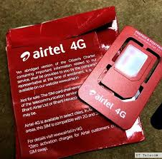

**Consumer goods:** Airtel sim

**Advertisement :**

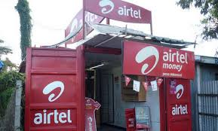

**A specialty good:** Airtel mobile app

**Cool factor:** cheaper call ,cheap internet packs,

**Product at its maturity:**Airtel sim cards

**A product in decline:**

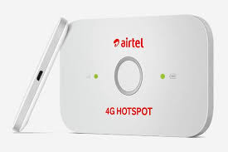

**Local brand:** Nivia Sports

**Product line:** Step out and play

**:**

**Consumer goods:** playing equipments such as footballs, bats ,balls

**Advertisement :**

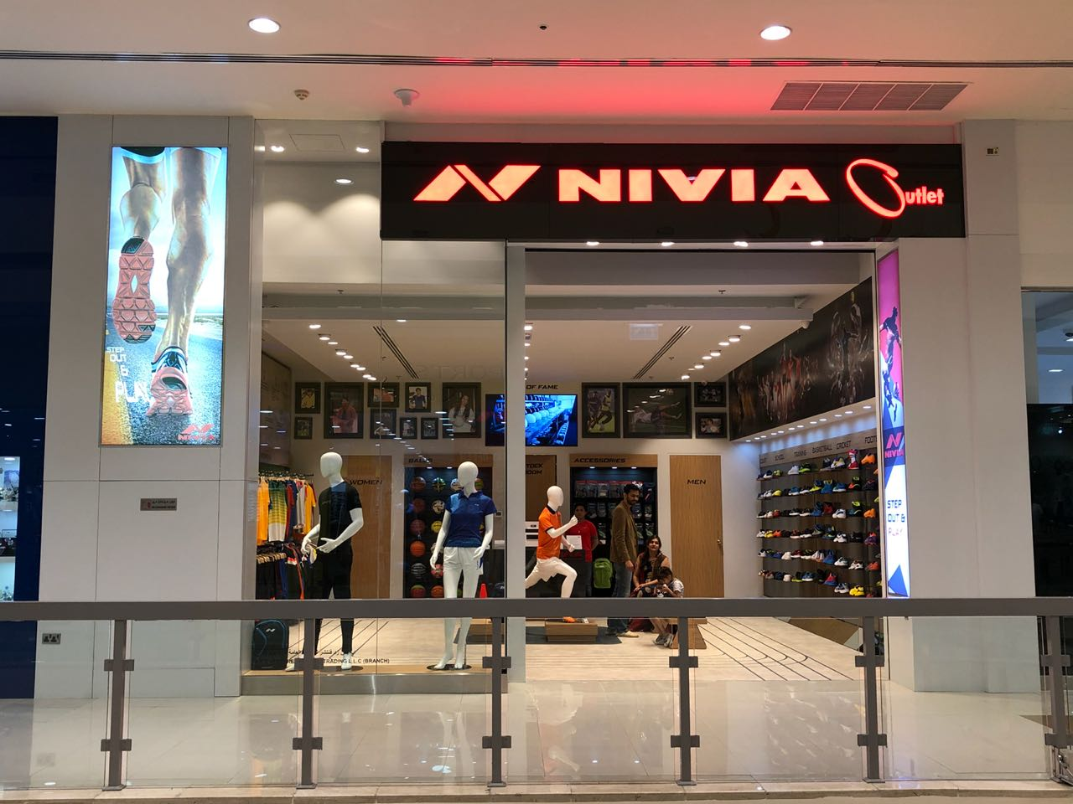

**A specialty good:**



Apple mobiles

**Product line:** All new,for a better you

**Consumer goods**: iPhone, iPad, Mac, iPod, Apple Watch, Apple TV,

**Non-durable product or service:** it assumes first owners of macOS and tvOS devices keep them four years, while iOS and watchOS devices last for three years.

**Advertisement :**

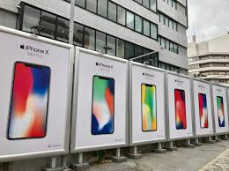

**A specialty good:**  iphone x

**Cool factor:** smooth touch , security

**Product at its maturity**: iphone se,apple watch series 1